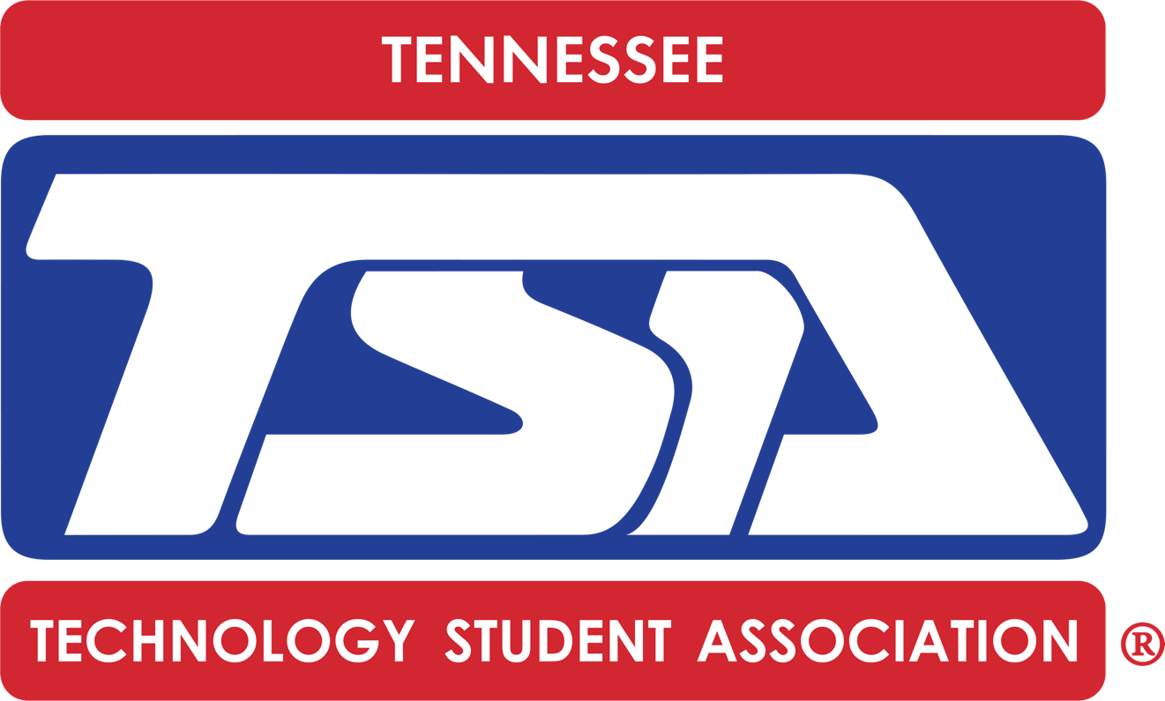
2019-20
Competitive Events Offered and Number of Entries per Chapter

 | MIDDLE SCHOOL EVENTS
Competitive Event | Regional Conference | State Conference
Biotechnology | - | 1 Team
CAD Foundations | - | 2 Individuals
Career Prep | 3 Individuals | 1 Individual
Challenging Technology Issues | 3 Teams | 1 Team
Chapter Team | 2 Teams | 1 Team
Children’s Stories | 2 Teams | 1 Team
Coding | - | 1 Team
Community Service Video | - | 1 Individual or Team
Construction Challenge | - | 1 Team
Digital Photography | - | 1 Individual
Dragster | - | 2 Individuals
Electrical Applications | - | 2 Individuals
Essays on Technology | - | 1 Individual
Flight | - | 2 Individuals
Forensic Technology | 2 Teams | 1 Team
Inventions and Innovations | - | 1 Team
Junior Solar Sprint | - | -
Leadership Strategies | 2 Teams | 1 Team
Mass Production | - | 1 Team
Mechanical Engineering | - | 1 Team
Medical Technology | 2 Teams | 1 Team
Microcontroller Design | - | 1 Team
Off the Grid | - | 1 Team
Prepared Speech | 2 Individuals | 1 Individual
Problem Solving | 2 Teams | 1 Team
Promotional Marketing | - | 2 Individuals
STEM Animation | - | 1 Team
Structural Engineering | 3 Teams** | 1 Team
System Control Technology | - | 1 Team
Tech Bowl | 3 Teams | 1 Team
Technical Design | - | 1 Team
VEX Robotics (IQ and/or VRC) | - | 3 Teams*
Video Game Design | - | 1 Team
Website Design | - | 1 Team
Fundamentals of Information Technology | - | 2 Individuals
Cybersecurity | - | 2 Individuals
Data Science and Analytics | - | 2 Teams

*If the VEX state contest team count exceeds the maximum capacity for our facility space, the TSA state advisor will notify the chapter advisors, and entries will be reduced to two teams per chapter.

**The regional structural contests for both middle and high school will only complete the qualification and stress testing. Students will NOT build a second bridge onsite at regionals due to time constraints.

HIGH SCHOOL EVENTS
Competitive Event | Regional Conference | State Conference
3D Animation | - | 1 Team
Animatronics | - | 1 Team
Architectural Design | - | 1 Individual or Team
Biotechnology Design | - | 1 Team
Board Game Design | 3 Teams | 1 Team
Chapter Team | 2 Teams | 1 Team
Children’s Stories | 3 Individuals or Teams | 1 Individual or Team
Coding | - | 1 Individual or Team
CAD, Architecture | - | 1 Individual
CAD, Engineering | - | 1 Individual
Computer Integrated Manufacturing (CIM) | - | 1 Team
Debating Technological Issues | 3 Teams | 1 Team
Digital Video Production | - | 1 Team
Dragster Design | - | 2 Individuals
Engineering Design | 3 Teams | 1 Team
Essays on Technology | - | 1 Individual
Extemporaneous Speech | 2 Individuals | 1 Individual
Fashion Design and Technology | - | 1 Team
Flight Endurance | - | 2 Individuals
Forensic Science | 2 Teams | 1 Team
Future Technology Teacher | 2 Individuals | 2 Individuals
Music Production | - | 1 Team
On Demand Video | - | 1 Team
Photographic Technology | - | 1 Individual
Prepared Presentation | 2 Individuals | 1 Individual
Promotional Design | - | 2 Individuals
Scientific Visualization (SciVis) | - | 1 Team
Software Development | - | 1 Team
Structural Design and Engineering | 3 Teams** | 1 Team
System Control Technology | - | 1 Team
Technology Bowl | 3 Teams | 1 Team
Technology Problem Solving | 2 Teams | 1 Team
Transportation Modeling | - | 1 Individual
VEX Robotics (VRC) | - | 3 Teams*
Video Game Design | - | 1 Team
Webmaster | - | 1 Team
Cybersecurity | - | -
IT Fundamentals | - | -

*If the VEX state contest team count exceeds the maximum capacity for our facility space, the TSA state advisor will notify the chapter advisors, and entries will be reduced to two teams per chapter.

**The regional structural contests for both middle and high school will only complete the qualification and stress testing. Students will NOT build a second bridge onsite at regionals due to time constraints

